**About:**

There will be section of about where there will be some basic information of cyber-100 and about the organization.

**Services:** How long its available? Example: 24/7

**Social Media Links:** Example: Facebook, Whatsapp etc.

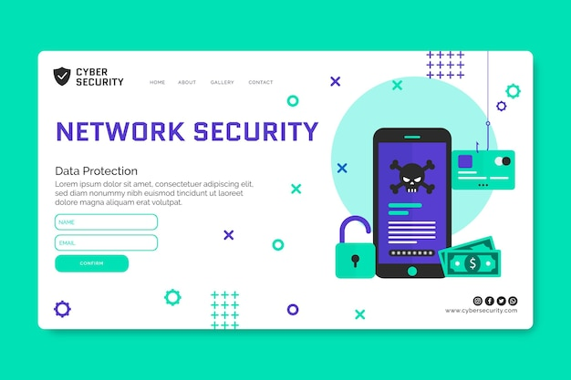

**This can be considered as an example.**

**Home:** In about section there will be home section where a template like the picture can be added. We can modify, edit or delete the options according to our demands and necessities.

**About:** In about section, there needs to be details of the organization. Examples: Services, Social Meda links etc. can be kept there.

**Gallery:** It varies from organization to organization.

**Contact:** There needs to be a contact section. Example: Phone, Whatsapp, Facebook.

**Login:** Login section is required for every website.